


Practical Information
Thank you for your participation in the Prince of Wales Hospital constraint-induced movement therapy program. We look forward to having you with us. Here is some practical information as a guide.
Dates: _____________________________________
Times: 9am-1pm. Please note that therapy will start promptly at 9am.
Location: Occupational Therapy Treatment Room
Level 1, High Street Entrance
Prince of Wales Hospital
Randwick, 2031
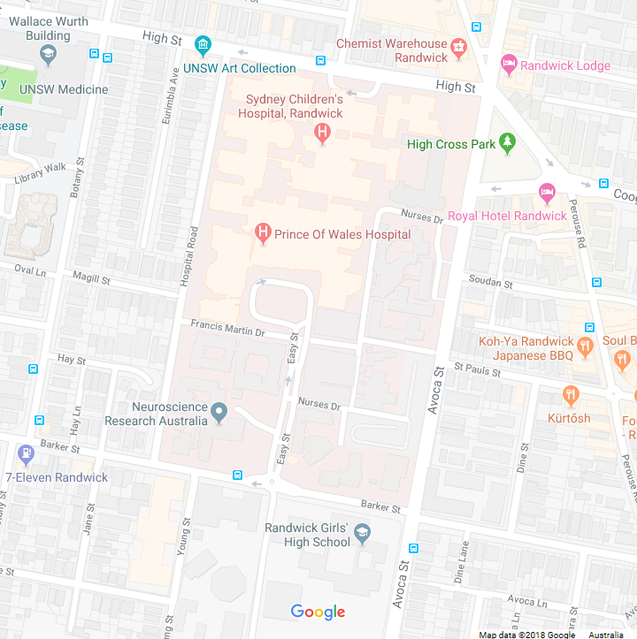

What to wear: Please wear comfortable clothing and comfortable shoes (no thongs, sandals or slides.
What to bring: Morning tea each day (snacks and drinks)
Jumper
Daily homework sheets (issued on first day)
Transportation:
Public transport – Buses run from Central Station to the corner of Belmore Rd and High Street.
Drop off location - The High Street entrance has 5 minute drop off zones.
Parking - Paid parking is located at the Barker Street Entrance and costs up to $30 per day.
Additional Appointment Times:
Initial assessment: Day: ___________________________________
Date: ___________________________________
Time: ___________________________________
Location: ________________________________

Final assessment: Day: ____________________________________
Date: ___________________________________
Time: ___________________________________
Location: ________________________________
Please let us know ASAP if you can no longer attend.
Clare Griffin
Occupational Therapist
Prince of Wales Hospital
9382 5021

