


Practical Information
Thank you for your participation in the St George Hospital constraint-induced movement therapy program. We look forward to having you with us. Here is some practical information as a guide.
Dates: ______________________________________
Times: 9am-1pm. Please note that therapy will start promptly at 9am.
Location: _________________________________________________________
_________________________________________________________
_________________________________________________________
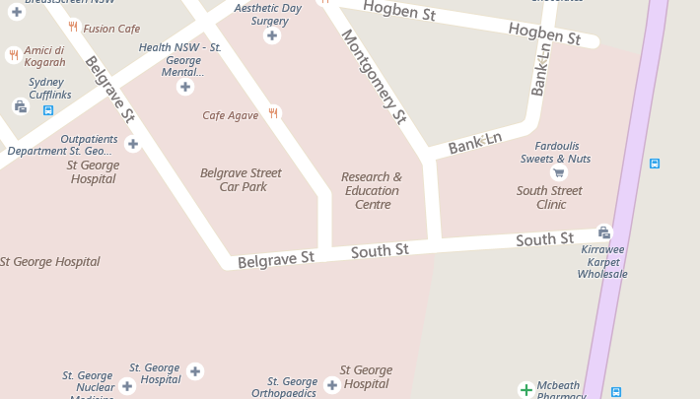
Princes Highway

What to wear: Please wear comfortable clothing and comfortable shoes (no thongs, sandals or slides.
What to bring: Morning tea each day (snacks and drinks)
Jumper
Daily homework sheets (issued on first day)

Transportation:
Public transport – Kogarah train station is a 10-15 minute walk from St George Hospital. Bus stops are located in several locations around Kogarah. To plan your trip please visit: https://transportnsw.info/trip#/
Drop off location - Wicks lane next to the Research and Education Centre.
Parking - Paid parking on South Street in the multi-level car park with lift access. One week parking will cost $22. Please inform your therapist at your assessment if you will require this as a form will need to be completed by us.

Additional Appointment Times:
Initial assessment: Day: ___________________________________
Date: ___________________________________
Time: ___________________________________
Location: ________________________________

Final assessment: Day: ____________________________________
Date: ___________________________________
Time: ___________________________________
Location: ________________________________

Please let us know ASAP if you can no longer attend.
Callie Bennett
Occupational Therapist
St George Hospital
9113 2395

