


Practical Information
Thank you for your participation in the Sutherland Hospital constraint-induced movement therapy program. We look forward to having you with us. Here is some practical information as a guide.
Dates: ______________________________________
Times: 9am-1pm. Please note that therapy will start promptly at 9am.
Location: Sutherland Hospital – Corner of Kareena Road and The Kingsway, Caringbah
Allied Health – Level 2 – Directly next to The Street Canteen
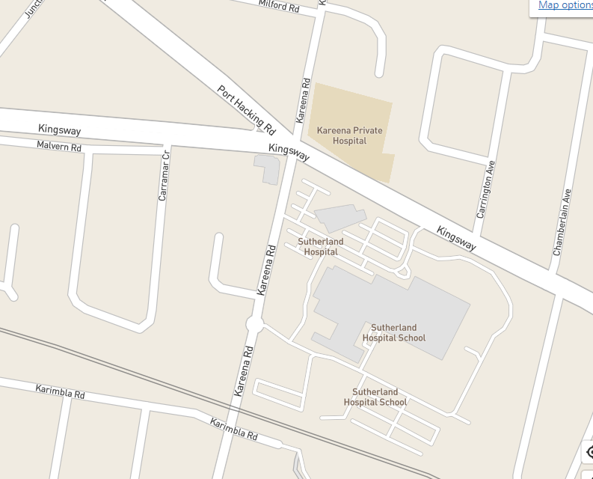
What to wear: Please wear comfortable clothing and comfortable shoes (no thongs, sandals or slides.
What to bring: Morning tea each day (snacks and drinks)
Jumper
Daily homework sheets (issued on first day)

Transportation:
Public transport – Caringbah train station is a 10-15 minute walk from Sutherland Hospital.
There is a bus stop directly in front of the hospital. Buses 971, 978, 969 and 986 are examples of bus lines that stop here. To plan your trip please visit: https://transportnsw.info/trip#/
Transdev link buses are also available for some Shire residents. Please visit: https://www.transdevlink.com.au/
Drop off location - From the Kingsway entry: at the main hospital entrance, Level 2
From Kareena Rd: at the rear hospital entrance, Level 1. Take lifts to level 2 – exit directly opposite Allied Health
Parking - Paid parking is available in the multi-level car park with lift access. Access via Kareena Rd entrance. Concessional parking is available.
Additional Appointment Times:
Initial assessment: Day: ___________________________________
Date: ___________________________________
Time: ___________________________________
Location: ________________________________

Final assessment: Day: ____________________________________
Date: ___________________________________
Time: ___________________________________
Location: ________________________________
Please let us know ASAP if you can no longer attend.

Elise Klumpes-Grant

Occupational Therapist
Sutherland Hospital
9540 8300

