REPERFUSION INJURY
APOPTOSIS
EMPHYSEMA
AORTIC DISSECTION
MENINGITIS
CHRONIC INFLAMMATION
PARANEOPLASTIC SYNDROMES & CANCER CACHEXIA
STREPTOCOCCI
DIC
DMT1 & DIABETIC KETOACIDOSIS
ISCHAEMIC BOWEL
ARDS
MECHANISMS OF CELL INJURY
PULMONARY EMBOLISM
ACUTE PANCREATITIS
MULTIPLE SCLEROSIS
VASCULAR CHANGES IN ACUTE INFLAMMATION
PLATELETS IN HAEMOSTASIS
TUMOUR INVASION
BORDETELLA PERTUSSIS
INFLUENZA VIRUS
HYPERTROPHIC CARDIOMYOPATHY
SEPTIC SHOCK
TYPE I HYPERSENSITIVITY
COMPLEMENT IN INFLAMMATION
NEPHROTIC SYNDROME
PERNICIOUS ANAEMIA
HEPATITIS D VIRUS
HEPATITIS C VIRUS
VON WILLEBRAND DISEASE
ASBESTOS RELATED LUNG DISEASE
THROMBUS FORMATION
TYPE IV HYPERSENSITIVITY
NIESSERIAL INFECTIONS
VITAMIN K
TYPE II HYPERSENSITIVITY
MYCOBACTERIUM TUBERCULOSIS
CLOSTRIDIAL INFECTIONS
TYPE III HYPERSENSITIVITY
HEPATITIS B VIRUS
REPERFUSION INJURY

DEFINITION: Further cell death, via necrosis or apoptosis, following restoration of blood flow to ischaemic tissues. Reperfusion injury is clinically important in conditions as MI and stroke.

PROPOSED MECHANISMS:
- Increased generation of oxygen free radicals- incomplete reduction of oxygen by damaged mitochondria, or because of the action of oxidases derived from leukocytes, endothelial cells, and parenchymal cells. Cellular antioxidant defence mechanisms may also be compromised.
- Promotion of the mitochondrial permeability transition by ROS, which precludes mitochondrial energisation and cellular ATP recovery, leading to cell death
- Inflammation caused by cytokine production and increased expression of adhesion molecules by hypoxic cells; this causes neutrophil recruitment and inflammation, leading to further tissue damage
- Activation of complement, which binds to IgM antibodies in ischaemic tissue when blood flow resumes. They are then activated and cause tissue injury.

APOPTOSIS

DEFINITION: A tightly regulated process of programmed cell death, in which a cells plasma membrane remains intact while enzymes degrade the cells DNA and proteins.
A noninflammatory process, which ends with the cell becoming a target for phagocytosis.
It serves to eliminate unwanted or potentially harmful cells, and may be either pathological or physiological.

CAUSES:
- Physiological
  - Programmed cell destruction during embryogenesis (developmental atrophy)
  - Hormone dependent involution in the adult e.g. menstruation, menopause
  - Cell deletion in proliferating cell populations e.g. intestinal crypt epithelia
  - Death of cells that have served their useful purpose e.g. post-inflammatory or post-immune response. Occurs because cells are deprived of survival signals (such as growth factors)
  - Elimination of potentially harmful self-reactive lymphocytes
  - Cell death induced by cytotoxic T-cells
- Pathological
  - Cell death secondary to injurious stimuli e.g. radiation and cytotoxic anticancer drugs
  - Viral diseases e.g. viral hepatitis
  - Atrophy in parenchymal organs after duct obstruction
  - Cell death in tumours

EXAMPLES OF APOPTOSIS
- Apoptosis after growth factor deprivation
- DNA damage-mediated apoptosis (involves tumour suppressor gene p53)
- Apoptosis induced by TNF family of receptors
- Cytotoxic T-cell mediated

EMPHYSEMA

DEFINITION: Abnormal permanent enlargement of the airspaces distal to the terminal bronchiole, accompanied by destruction of their walls and without obvious fibrosis.

PATHOGENESIS
- Mild chronic inflammation throughout the airways, parenchyma, and pulmonary vasculature. Macrophages, CD8+ and T Lymphocytes, and neutrophils are increased
- The protease-antiprotease theory: an imbalance between proteases (mainly elastase) and antiproteases in the lung. α-1 anti-trypsin (which is synthesised in the liver and is present in the serum, tissue fluids, and macrophages) is a major inhibitor or proteases secreted by neutrophils during inflammation.
- The normal α1-AT phenotype is PiMM; PiZZ is associated with α1-AT deficiency and emphysema
- Other antielastases include secretory leukoprotease inhibitor (mucous) and α1-macroglobulin (serum)
- The principal elastase activity is derived from neutrophils; neutrophil elastase is capable of digesting human lung; this digestion is inhibited by α1-AT

Neutrophils are normally sequestered in the lung (more in the lower zones), with a few in the alveolar space. Any stimulus that increases either the number of leukocytes in the lung, or the release of their elastase-containing granules, increases elastolytic activity. Stimulated neutrophils also release O2 free radicals, which inhibit α1-AT activity. With low levels of serum α1-AT, the process of elastic tissue destruction is unchecked, with consequent emphysema.

SMOKING IN EMPHYSEMA
- Tobacco smoke contains free radicals which deplete the antioxidant mechanisms of the lungs (superoxide dismutase, glutathione)
- This incites tissue damage and activation of neutrophils
- Native antiproteases are inactivated, resulting in a functional α1-AT deficiency

- Smoke particles cause an influx of neutrophils and macrophages (via stimulation of neutrophil chemotactic factors IL-8, LTB-4, TNF) with resulting secretion of proteases

- Increased proteases, plus oxygen free radicals, cause centriacinar damage

- Tissue breakdown is enhanced by inactivation of protective antiproteases by ROS in cigarette smoke

AORTIC DISSECTION

DEFINITION: Dissection of blood between and along the laminar planes of the media, with the formation of a blood filled channel within the aortic wall, which often ruptures outward causing massive haemorrhage

PATHOGENESIS:
- Risk factors:
  - HTN (main RF)
  - Marfans syndrome (connective tissue disorder)
  - Arterial cannulation
  - Pregnancy
- Process of development:
  - Medial degeneration
  - Intimal tear
  - Blood flow and haematoma along the laminar planes of the aorta

CLASSIFICATION:
By the site of involvement:
- Type A
  - Proximal lesions
  - Involve either ascending only or both ascending and descending
- Type B
  - Distal lesions
  - Begin distal to the subclavian artery

CONSEQUENCES:
- Death secondary to rupture into the pericardial, pleural, or peritoneal cavity
  - Cardiac tamponade
  - Aortic insufficiency
  - MI
- Retrograde dissection into the aortic root
  - Aortic valve disruption
- Extension into great arteries of the neck, or into the coronary, renal, mesenteric, or iliac arteries
  - Obstruction
- Compression of spinal arteries
  - Transverse myelitis

MENINGITIS

DEFINITION: An inflammatory process of the leptomeninges and CSF within the subarachnoid space. Usually caused by an infection, but chemical meningitis may occur; also secondary to cancer and lymphoma

CLASSIFICATION:
- Infectious
  - Acute pyogenic- bacterial
  - Aseptic- viral
  - Chronic- TB, spirochetal, cryptococcal
- Non-infectious
  - Chemical meningitis
  - Meningeal carcinomatosis
  - Meningeal lymphomatosis

CAUSES:
The microorganisms that cause acute pyogenic meningitis vary with the age of the affected individual. In neonates, they include Escherichia coli and the group B streptococci; at the other extreme of life, Streptococcus pneumoniae and Listeria monocytogenes are more common. Among adolescents and in young adults, Neisseria meningitidis is the most common pathogen, with clusters of cases causing frequent public health concerns. The introduction of immunization against Haemophilus influenzae has markedly reduced the incidence of meningitis associated with this organism in the developed world; the population that was previously at highest risk (infants) now has a much lower overall risk of meningitis, with S. pneumoniae being the most prevalent organism.

CHRONIC INFLAMMATION

DEFINITION: Inflammation of prolonged duration (over weeks or months) in which active inflammation, tissue destruction, and attempts at repair are proceeding simultaneously.

CAUSES:
- Persistent infections
  - TB
  - Treponoma pallidum (syphilis)
  - Viruses
  - Fungi- cryptococcus neoformans
  - Parasites- schistosomiasis
- Prolonged exposure to toxic agents
  - Exogenous
    - Silica
    - Beryliosis
  - Endogenous
    - Toxic lipid components leading to atherosclerosis
- Autoimmunity
  - RA
  - SLE

MORPHOLOGICAL FEATURES
- Infiltration with mononuclear cells
- Tissue destruction
- Ongoing attempts at healing
  - Connective tissue replacement of damaged tissue
  - Angiogenesis
  - Fibrosis

CELL TYPES PRESENT IN CHRONIC INFLAMMATION
- Macrophage
- Part of the mononuclear phagocyte system
- Kupffer cells (liver)
- Sinus histiocytes (spleen and LN)
- Alveolar macrophages (lungs)
- Lymphocytes
- T and B cells
- Eosinophils
- IgE and parasite infections
- Mast cells
- Bind the Fc portion of IgE antibody
- Neutrophils

MACROPHAGES IN CHRONIC INFLAMMATION
- Activated macrophages secrete a wide variety of biologically active products that, if unchecked, result in tissue injury and fibrosis
- Persistent accumulation of macrophages is mediated by:
  - Recruitment of macrophages from the circulation
    - The most important factor
    - Process is similar to the recruitment of neutrophils
    - Ongoing expression of adhesion molecules
    - Ongoing expression of chemotactic factors
      - Chemokines
      - C5a
      - TGFα
      - Collagen and fibronectin breakdown products
  - Local proliferation of macrophages
  - Immobilisation of macrophages within the site of inflammation

PRODUCTS OF ACTIVATED MACROPHAGES
Organised in a functional way:
- Causing tissue injury
- Toxic oxygen metabolites
- Proteases
- Neutrophil chemotactic factors
- Coagulation factors
- AA metabolites
- NO
- Causing fibrosis
- Growth factors- PDGF, FGF, TGFβ
- Fibrogenic cytokines
- Angiogenesis factors
- Collagenases (remodelling)

PARANEOPLASTIC SYNDROMES

DEFINITION: Symptom complexes occurring in ~10% of patients with malignancy that can’t be easily explained by local or distal spread, or by elaboration of hormones from the tissue the tumour arose from.
- May be the earliest presentation of an occult neoplasm
- May result in significant clinical problems
- May mimic metastatic disease

MAIN TYPES OF PARANEOPLASTIC SYNDROMES

Organised according to the main system affected:

- Endocrine- caused by ectopic hormone production; the cancer cells are NOT endocrine in origin
  - Cushing Syndrome
    - Small cell lung CA
    - ACTH
  - SIADH
    - Small cell lung CA
    - ADH
  - Hypercalcaemia
    - The most common paraneoplastic syndrome
    - Caused by production of calcaemic humoral substances by extraosseous neoplasms
    - NOT due to osteolysis from primary or metastatic bone CA
    - Squamous cell lung CA, breast CA, renal CA
    - Parathyroid-hormone-related protein- regulates calcium transport
    - IL-1, TGF-α, TNF
  - Hypoglycaemia
    - Hepatocellular CA
    - Insulin
  - Carcinoid syndrome
    - Pancreatic CA, bronchial carcinoid
    - Serotonin, bradykinin
  - Polycythaemia
    - Renal CA
    - EPO
- Nerve and muscle syndromes
  - Myasthenia
    - Bronchogenic CA
    - Immune mediated
  - Disorders of PNS and CNS
    - Breast CA
    - Immune mediated

- Dermatological disorders
  - Acanthosis nigricans
    - Lung CA
    - Immune mediated
  - Dermatomyositis
    - Breast CA
    - Immune mediated
- Soft tissue disorders
  - Hypertrophic osteoarthropathy (& clubbing)
    - Bronchogenic CA
    - Mechanism unknown
- Vascular disorders
  - Venous thromboembolism
    - Bronchogenic CA
    - Tumour products

CANCER CACHEXIA

DEFINITION: Progressive loss of body fat and lean body mass accompanied by profound weakness, anorexia, and anaemia. There is equal loss of fat and muscle.

CAUSES: The causes are obscure, but are not due to the nutritional demands of the tumour. Cancer cachexia is likely related to cytokine production.
- Anorexia
  - Abnormalities in taste
  - Disturbance of central control of appetite
- Increased basal metabolic rate

CYTOKINES INVOLVED
- Synergistic with TNF
  - IL-1, IFN-γ, Leukaemia inhibitory factor
- Tumour produced soluble factors
  - Proteolysis inducing factor (PIF)
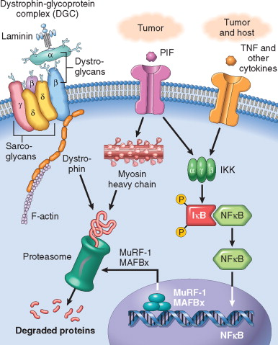
STREPTOCOCCI

DEFINITION: Facultative or obligate anaerobic Gram positive cocci that grow in pairs or chains and cause:
- Suppurative Infections
- Post-streptococcal Syndromes

CLASSIFICATION: The initial classification is by the pattern of haemolysis on blood agar
- α- Haemolytic- partial haemolysis
  - Strep pneumoniae
    - Adult community acquired pneumonia
    - Meningitis
  - Strep viridans
    - Endocarditis
  - Strep mutans
    - Dental caries
- β- Haemolytic- complete haemolysis
  - Further divided into groups A-U (Lancefield groups) based on the antigenic differences in the C-carbohydrate
- γ-Haemolytic- No haemolysis
  - Rarely pathogenic

β-HAEMOLYTIC STREPTOCOCCI

Contain 2 important antigens:
- C-carbohydrate- determines the Lancefield group
- M-protein- the most important virulence factor of Group A β-haemolytic strep

- Group A: Streptococcus Pyogenes- three types of pathogenesis
  - PYOGENIC
    - Local- Impetigo, cellulitis
    - Disseminated- Sepsis
  - TOXIGENIC
    - Caused by exotoxin production- Scarlet fever, toxic shock
  - IMMUNE MEDIATED
    - Post-streptococcal syndromes- Rheumatic fever, acute glomerulonephritis
- Group B: Streptococcus Agalactiae
  - PYOGENIC
    - Neonatal sepsis, neonatal meningitis, chorioamnionitis
- Group D: Enterococcus- previously a Lancefield group subset of β-haemolytic strep, enterococcus is now considered a separate genus

STREPTOCOCCAL VIRULANCE FACTORS

Group A β-haemolytic strep and α-haemolytic strep have antiphagocytic capsules and protective capsular antibodies, as well as multiple cytotoxic enzymes and exotoxins.
Group B β-haemolytic strep have no cytotoxic enzymes or exotoxins, and there is no evidence for immunological disease. However they do still have an antiphagocytic capsule and protective capsular antibodies.

- Capsules that resist phagocytosis
  - Composed of hyalonuric acid, a normal component of the body that humans are tolerant to
  - S. pyogenes & S. pneumoniae mainly, but most strep have this
- M-protein
  - Interferes with ingestion by phagocytes by inhibiting the alternative pathway of complement
  - Found on Type A (S. Pyogenes)
  - Antistreptococcal M protein antibody is implicated in the development of rheumatic fever
- Complement C5a peptidase
  - Degrades chemotactic peptide
  - S. Pyogenes
- Pneumolysin
  - Destroys host-cell membranes and damages tissue
  - S. Pneumoniae
- Exotoxin
  - Pyogenic Exotoxin A
    - Causes release of cytokines from T-helper cells
    - Causes the rash and fever in Scarlet Fever
  - Exotoxin B
    - A protease that rapidly destroys tissue
    - S. Pyogenes- necrotising fasciitis
- HMW glucans
  - Promote bacterial aggregation
  - S. mutans
- Metabolism of sucrose to lactic acid
  - S. Mutans

DISSEMINATED INTRAVASCULAR COAGULATION

DEFINITION: An acute, subacute, or chronic thrombohaemorrhagic disorder occurring as a secondary complication in a variety of diseases. It is characterised by activation of the coagulation sequence that leads to the formation of microthrombi throughout the microvasculature of the body. As a consequence of the thrombotic diathesis, there is consumption of platelets, fibrin, and coagulation factors, and secondary activation of fibrinolytic mechanisms.

MAJOR CAUSES:
Divided into five groups:
- Obstetric complications
  - Placental abruption
  - Amniotic fluid embolism
  - Retained foetus
- Infections
  - Gram negative sepsis
  - Malaria
  - Meningococcemia
- Neoplasms
  - Carcinoma of the lung
  - Carcinoma of the pancreas
  - Acute promyelocytic leukaemia
- Massive tissue injury
  - Trauma
  - Burns
  - Extensive surgery
- Miscellaneous
  - Snakebite
  - Heatstroke
  - Liver disease

PATHOGENESIS:
Two major mechanisms:
- Release of tissue factor or thrombogenic substances into the circulation
  - Multiple causes
    - From placenta
    - From granules of leukaemic cells
    - Endotoxins cause activated monocytes to release IL-1 and TNF, which cause increased expression of TF on endothelial cells
    - TF causes activation of the extrinsic pathway of coagulation
  - Result in an overall shift towards procoagulation
- Widespread injury to endothelial cells causes:
  - Release of tissue factor
  - Promotion of platelet aggregation
  - Activation of the intrinsic pathway of coagulation

CONSEQUENCES OF DIC
- Widespread deposition of fibrin within the microcirculation
  - Ischaemia
  - Haemolytic anaemia
    - Damage to RBC as they pass through the narrowed microvasculature
- Haemorrhagic diathesis: consumptive coagulopathy
  - Results from consumption of platelets and clotting factors as well as activation of plasminogen
  - Fibrinolysis leads to formation of fibrin degradation products, which inhibit platelet aggregation and fibrin polymerisation

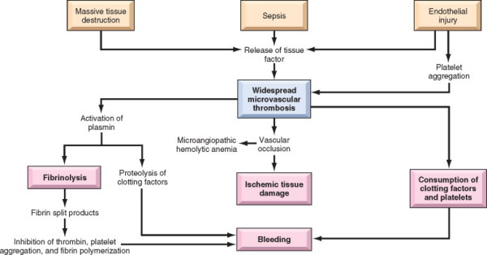

THE FIBRINOLYTIC CASCADE

- GENERATION OF PLASMIN
  - From factor XII dependent pathway
  - By plasminogen activators
    - U-PA- urokinase-like plasminogen activator, which is present in plasma
    - T-PA- tissue-type plasminogen activator, which is the most important one, and is most active when attached to fibrin
- BREAKDOWN OF FIBRIN BY PLASMIN
  - Results in fibrin split products e.g. D-dimer

Free plasmin complexes to α2-plasmin inhibitor and is inactivated.

THE COMMON COAGULATION PATHWAY
Occurs following the activation of Factor X via the intrinsic/extrinsic pathways and has three main steps:
- The conversion of prothrombin to thrombin
- The conversion of fibrinogen to fibrin
- Fibrin cross-linking
These events occur on a phospholipid complex scaffolding and require the presence of calcium, which is released from platelet δ-granules.

Activated factor X, with the cofactors factor Va and calcium, convert prothrombin to thrombin. Thrombin then converts fibrinogen to fibrin in the presence of calcium. Fibrin is then stabilised and cross-linked by activated factor XIII.

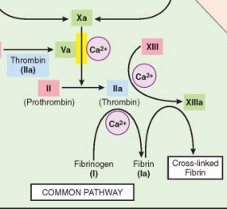

DIABETES MELLITUS TYPE 1

DEFINITION: A hyperglycaemic disorder characterised by an absolute deficiency of insulin, caused by immunologically mediated pancreatic β-cell destruction by T-lymphocytes.

STAGES IN DEVELOPMENT:
- Genetic predisposition
- Precipitating event leading to T-cell destruction of islet cells, which progresses throughout the course of the disease
- Overt immunologic abnormalities with normal insulin release
- Progressive loss of insulin release, but glucose remains normal
- Over diabetes with loss of insulin release and hyperglycaemia

LONG-TERM COMPLICATIONS OF DMT1

- Macrovascular
  - Atherosclerosis- MI, PVD/gangrene
  - Renal arteriosclerosis- nephrosclerosis
  - HTN
  - CVA
- Microvascular (Diabetic Microangiopathy)- diffuse thickening of capillary basement membrane
  - Small vessels
    - Cerebral microangiopathy
  - Kidneys
    - Diabetic nephropathy
    - Glomerulosclerosis
    - Renal failure +/- dialysis
  - Retina
    - Diabetic retinopathy
  - Nerves
    - Autonomic neuropathy
    - Peripheral neuropathy +/- diabetic foot problems
- Other
  - Cataracts & glaucoma
  - Pyelonephritis
  - Increased susceptibility to infection

DIABETIC KETOACIDOSIS

Originates with a disturbance of the insulin:glucagon ratio. An insulin deficiency combined with glucagon excess results in:
- Decreased peripheral utilisation of glucose
  - Causes increased gluconeogenesis and exacerbation of hyperglycaemia
  - This in turn leads to an osmotic diuresis with
    - Polyuria with ketonuria and glycosuria
    - Volume depletion and dehydration
- Stimulation of lipoprotein lipase
  - Excess breakdown of adipose stores
  - Increased free fatty acid levels
  - Hepatic production of ketone bodies from free fatty acids
  - Ketonaemia and ketonuria
- Metabolic ketoacidosis
  - Urinary excretion of ketones is impaired by dehydration
  - Plasma hydrogen ion concentration increases
  - Protein catabolism releases ketogenic amino acids and worsens the ketotic state
  - If untreated, coma and eventual death result.

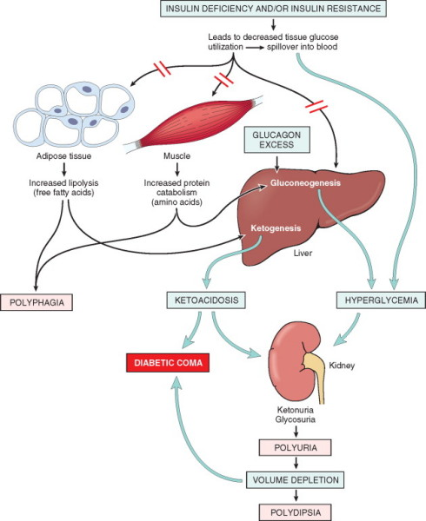
ISCHAEMIC BOWEL

DEFINITION: Ischaemic injury to the bowel that may be (1) transmural (all layers), (2) mural (mucosa and submucosa) or (3) mucosal. Almost always, transmural ischaemia is caused by mechanical compromise of the major mesenteric blood vessels. Mucosal or mural infarction more often result from acute or chronic hypoperfusion.

CAUSES:
- Arterial thrombus
  - Severe atherosclerosis
  - Dissecting aneurysm
  - Systemic vasculitis
- Arterial embolism
  - Cardiac vegetations
  - Aortic thromboembolism
- Venous thrombis
  - Hypercoagulable states
  - OCP
  - Invasive neoplasia
  - Intraperitoneal sepsis
- Non-occlusive ischaemia
  - CCF
  - Shock
  - Dehydration
  - Vasoconstrictive drugs
- Miscellaneous
  - Volvulus
  - Stricture
  - DM
  - Herniation

CLINICAL FEATURES:
- Transmural
  - Sudden onset severe abdominal pain and tenderness
  - Nausea and vomiting
  - Bloody diarrhoea/melaena
  - Shock and vascular collapse (late signs)
  - Decreased or absent bowel sounds
  - Acute abdomen with rigidity
- Mucosal and mural
  - Non-specific abdominal complaints
  - Intermittent bloody diarrhoea

ACUTE RESPIRATORY DISTRESS SYNDROME

DEFINITION: A clinical syndrome caused by diffuse alveolar capillary damage and characterised clinically by the rapid onset of severe life-threatening respiratory insufficiency, cyanosis, and arterial hypoxaemia. ARDS may progress to multiorgan failure and death.

CAUSES:
- Infection
  - Sepsis
  - Diffuse pulmonary infections
    - Viral
    - Mycoplasma
    - Pneumocystis pneumonia
  - Gastric aspiration
- Trauma
  - Head injury
  - Pulmonary contusions
  - Burns
- Inhaled irritants
  - Smoke
  - O2 toxicity
  - Irritants
- Chemical injury (drugs)
  - Heroin overdose
  - Aspirin
  - Barbituate overdose
- Haematological conditions
  - Multiple transfusions
  - DIC
- Other
  - Pancreatitis
  - Uraemia
  - Hypersensitivity reactions

50% of cases are associated with sepsis, diffuse lung infections, gastric aspiration, and head injury.

PATHOGENESIS

- Diffuse alveolar capillary damage
  - Increased vascular permeability
  - Alveolar flooding
  - Loss of diffusion capacity
  - Widespread surfactant abnormalities
- Activation of neutrophils and acute inflammation
  - Increased synthesis of IL-8 (and IL-1 & TNF) by pulmonary macrophages as early as 30 minutes following acute insult
  - Pulmonary sequestration and activation of neutrophils
  - Neutrophils release oxidants, proteases, PAF, and leukotrienes as well as maintaining the inflammatory cascade
- Organisation with scarring
  - Resolution is unusual; more commonly (if multiorgan failure and death do not occur) there is organisation of the fibrin-rich exudate and intra-alveolar fibrosis

CLINICAL COURSE
- Signs and symptoms of the predisposing cause
- Profound dyspnoea and tachypnoea with a normal CXR
- Cyanosis, hypoxaemia, and respiratory failure with diffuse bilateral infiltrates on CXR
- Hypoxaemia unresponsive to O2 therapy, with a respiratory acidosis

OUTCOMES
- Chronic lung disease resulting from intra-alveolar fibrosis and scarring
- Multiorgan failure and death (ARDS has a 60% mortality rate)

MECHANISMS OF CELL INJURY

- DEPLETION OF ATP
  - Secondary to decreased oxidative phosphorylation in the mitochondria
  - Causes loss of energy dependent cellular function with resultant defects in protein synthesis
- LOSS OF CELL MEMBRANE INTEGRITY
  - Causes:
    - Damage to mitochondria
    - Lysosome rupture
    - Enzymatic digestion of cellular components and cytoskeletal damage
    - Loss of cellular contents
- INCREASED CELLULAR CALCIUM
  - Causes protein breakdown and DNA damage
- ROS
  - Causes protein breakdown and DNA damage

IRREVERSIBLE CELL INJURY

DEFINITION: Continuing stress causes cells to reach a point where they are no longer able to reverse or repair the damage that has occurred. The end result is cell death via apoptosis or necrosis.

CHARACTERISED BY:
- Severe mitochondrial damage
  - Irreversible mitochondrial permeability transition
  - Lack of oxidative phosphorylation and ATP generation
  - Leakage of cytochrome C and other pro-apoptotic proteins
  - Remains after resolution of the original injury
- Disruption of cellular membranes
  - Caused by swelling and disruption of lysosomes
  - Degradation of cytoplasmic and nuclear components by acid hydrolases
  - Results in massive leakage of intracellular materials and massive influx of calcium

TISSUE-SPECIFIC INTRACELLULAR PROTEINS
- Cardiac muscle- CK and troponin
- Liver bile duct epithelium- ALP
- Hepatocytes- transaminases

PULMONARY EMBOLISM

DEFINITION: A detached intravascular solid, liquid, or gaseous mass that is carried by the blood to lodge in the pulmonary circulation

PREDISPOSING FACTORS:
- Hypercoagulable states
  - Primary (genetic)
    - Factor V Leiden deficiency
    - Mutation in prothrombin gene
    - Homocysteinaemia
    - Protein C + S deficiency
  - Secondary (acquired)
    - Prolonged bed rest
    - Tissue damage
    - Obesity
    - Cancer
    - Antiphospholipid syndrome
    - Hyperoestrogenic states (e.g. pregnancy, OCP)
- Other underlying conditions
  - Fractures of long bones
  - Decompression sickness
  - Labour and the post partum period
  - Malignancy

CLINICAL SEQUELAE OF PE: Will depend on size and number
- Large pulmonary emboli
  - Sudden death (when >60% of the circulation is compromised)
  - Severe chest pain
  - Dyspnoea
  - Shock
  - Increase in temperature
  - Right heart failure with associated signs
- Small emboli in patients with adequate pulmonary circulation
  - Transient chest pain
  - Cough
  - Pulmonary haemorrhage without infarct
  - 60-80% of small P.E. are clinically silent
- Small emboli in patients with inadequate pulmonary circulation
  - Dyspnoea
  - Tachypnoea
  - Fever
  - Chest pain
  - Cough and haemoptysis
  - Pleural rub
- Unresolved, multiple small emboli
  - Pulmonary hypertension
  - Pulmonary vascular sclerosis
  - Chronic right heart failure
- All sizes confer an increased risk of a second P.E. in the future

NON-THROMBOTIC PULMONARY EMBOLI
- Air
- Fat
- Amniotic fluid
- Tumour cells
- Foreign bodies

ACUTE PANCREATITIS

DEFINITION: a group of reversible lesions characterised by inflammation of the pancreas, ranging in severity from oedema and fat necrosis to parenchymal necrosis with severe haemorrhage

CAUSES:
- Metabolic
  - Alcoholism
  - Hypercalcaemia
  - Drugs
  - Genetic
- Mechanical
  - Trauma
  - Gallstones
  - Iatrogenic
- Vascular
  - Shock
  - Atheroembolism
  - Polyarteritis nodosa
- Infectious
  - Mumps
  - Coxsackievirus
  - Mycoplasma pneumoniae

PATHOGENESIS: Anatomic changes occur as a result of autodigestion of the pancreatic substance by inappropriately activated pancreatic enzymes. There are three pathways of injury, all of which result in activation of pancreatic enzymes:
- Duct obstruction
- Acinar cell injury
- Defective intracellular transport
In particular, trypsinogen is activated to trypsin, leading to:
  - Interstitial inflammation and oedema
  - Proteolysis (protease)
  - Fat necrosis (lipase and phospholipase)
  - Haemorrhage (elastase)

Trypsin also converts prekallikrien and factor XII, activating the kinin, clotting, and complement systems.

MULTIPLE SCLEROSIS

DEFINITION: An autoimmune demyelinating disorder characterised by distinct episodes of neurological deficits, separated in time, attributable to white matter lesions separated in space.

CLINICAL FEATURES: Evolve as relapsing and remitting episodes of neurological deficit during variable intervals of time.
- Unilateral visual impairment
  - Optic neuritis
  - Retrobulbar neuritis
- Cranial nerve signs
- Ataxia
- Nystagmus
- Internuclear ophthalmoplegia
- Spinal cord lesions
  - Motor and sensory impairment of the trunk and limbs
  - Spasticity
  - Bladder dysfunction

PATHOGENESIS:
- Cellular immune response inappropriately directed against componants of the myelin sheath
- Chronic inflammation secondary to immune mechanisms occurs
- CD4+ TH1 T-cells react against self myelin antigens and secrete cytokines (eg IFN-γ) to activate macrophages
- Sclerotic plaques containing T-cells and macrophages are formed
- Chances of developing MS are increased by:
  - Genetic factors
    - The chance of MS is 15 times higher when a first-degree relative has the disease
  - Environmental factors
    - The relation of disease development to distance from the equator is now considered to be due to genetic differences in the populations involved
    - ?Microbial triggers

CSF EXAMINATION:
- Mildly elevated protein level
- 1/3 of cases show a moderate pleocytosis
- Increase in γ globulin and oligoclonal bands, representing the proliferation of B-cells

VASCULAR CHANGES IN ACUTE INFLAMMATION

- Vasodilation following transient constriction; induced by the action of NO and histamine on vascular smooth muscle
- Increased blood flow
- Increased Microvascular permeability
- Stasis- increased viscosity and concentration of RBC in small vessels
- Leukocyte margination and extravasation

MECHANISMS OF INCREASED VASCULAR PERMEABILITY

- Endothelial contraction- Immediate transient response
- Occurs in venules
- The most common mechanism
- Mediators:
  - Cytokines- IL-1, TNF, IFN-γ
  - Histamine
  - Bradykinin
  - Leukotrienes
  - Substance P
- Direct injury to the vessel- Immediate sustained response
  - Occurs in arterioles, capillaries, and venules
  - Caused by toxins, burns, and chemicals
- Delayed prolonged leakage
  - Begins after 2-12 hours
  - Involves venules and capillaries
  - Caused by radiation, burns, and bacterial toxins
- Leukocyte dependent injury
  - Occurs in venules, as wells as pulmonary and glomerular capillaries
  - A late response
- Increased transcytosis
  - Occurs in venules
  - Mediated by VEGF
- New blood vessel formation
  - At sites of angiogenesis

PLATELETS IN HAEMOSTASIS

FORMATION OF THE PRIMARY HAEMOSTATIC PLUG
- Adhesion
  - Vascular injury exposes circulating platelets to ECM components
    - Collagen
    - Proteoglycans
    - Fibronectin
    - Adhesive glycoproteins
  - vWF on exposed collagen links with platelet surface receptors
    - Glycoprotein 1b
    - Factor V
    - Factor IX
  - vWF-Gp1b bonds overcome the blood shear forces
- Activation
  - Secretion
    - Alpha granules
- Fibrinogen
- Fibronectin
- Factor V
- Factor VIII
- Platelet factor 4
- PDGF
- TGFβ
    - Delta granules –dense bodies
- ADP
- ATP
- Calcium
- Histamine
- Serotonin
- Adrenaline
  - Surface expression of phospholipid complexes
    - Providing a base for the coagulation cascade to work on
- Aggregation
  - ADP + TXA2 stimulate platelet aggregation
  - Formation of the primary haemostatic plug (reversible)

FORMATION OF THE SECONDARY HAEMOSTATIC PLUG
- Continuation of aggregation
  - Caused by ADP, TXA2, and thrombin
- Platelet contraction
  - Viscous metamorphosis
- Conversion of fibrinogen to fibrin

TUMOUR INVASION

INVASION OF THE EXTRACELLULAR MATRIX
- Detachment of the tumour cells from each other (disruption of e-cadherins)
- Attachment to matrix components via laminin and fibronectin
- Degradation of the ECM to create pathways for migration; requires active enzymatic degradation of the ECM components. Cleavage products of matrix components have growth promoting, angiogenic, and chemotactic properties. Three classes of proteases:
  - Serine proteases
  - Cystine proteases
  - Matrix metalloproteases- cleave Type IV collagen and basement membrane
- Migration of tumour cells- may result in vascular dissemination

FACTORS INFLUENCING DISTRIBUTION OF METASTASES- TISSUE TROPISM
- Tumour cell adhesion molecules whose ligands are expressed preferentially on the endothelial cells of target organs
- Chemokines for target tissues
- Chemoattractants liberated by some target organs that recruit tumour cells to the site
- Unpermissive environments of some target tissues PREVENTS metastases

BORDETELLA PERTUSSIS

Small, encapsulated, gram negative coccobacillus transmitted by airborne droplets that causes an acute, highly communicable illness known as whooping cough, which is characterised by paroxysmal coughing

PATHOGENESIS
- Attachment of B. Pertussis to the brush border of the bronchial epithelium and macrophages
- Production of pertussis toxin
  - Exotoxin
  - Composed of five polypeptides
  - Stimulates ADP (ADP-ribosylation) to attach to the G protein complex
  - Inactivates guanine nucleotide-binding proteins (inhibits signal transduction by chemokine seven-transmembrane G-protein coupled receptor)
  - Paralysis of cilia via induction of nitrous oxide
  - Inhibition of neutrophil bacteriocidal activity

CLINICAL FINDINGS
- Laryngotracheobronchitis
- Begins as an URTI
- Severe paroxysmal cough lasting 1-4 weeks
- Leukocytosis with profound lymphocytosis (up to 90%)
- Bronchial mucosal erosion, hyperaemia, and copious mucopurulant exudate
- Increased peribronchial LN

PREVENTION
- B. Pertussis vaccination (both killed bacteria and acellular types)
- Rates are currently increasing
  - ?Antigenic divergence?
  - ?Decreased numbers of immunisation?

INFLUENZA VIRUS

DEFINITION: A spherical virus containing eight helices of ssRNA, each encoding a single gene and each bound by a nucleoprotein that determines the type of influenza virus (A, B, C), and contained within a lipid bilayer. Influenza subtype is determined by (a) viral haemaglutinin (H1-H3) and (b) viral neuraminidase (N1 or N2).

PATHOGENESIS OF VIRAL PNEUMONIA (Pathogenesis of atypical pneumonias)
- ATTACHMENT of the virus to the upper respiratory tract epithelium
- NECROSIS of cells
- INFLAMMATORY RESPONSE
- ALVEOLAR INVOLVEMENT with interstitial inflammation and fluid in the alveolar spaces
- SECONDARY INFECTIONS with bacteria (e.g. Staphylococcus Areus, Streptococcus Pneumoniae)

ANTIGENIC DRIFT: Caused by mutations of the haemaglutinin and neuraminidase that allow the virus to escape most host antibodies. Results in epidemics.

ANTIGENIC SHIFT: Caused by replacement of the haemaglutinin and neuraminidase by recombinant RNA segments from animals, creating a new influenza virus. Results in pandemics.

HYPERTROPHIC CARDIOMYOPATHY

One of three heart diseases resulting from a primary abnormality in the myocardium- (a) dilated, (b) hypertrophic, (c) restrictive

DEFINITION: Massive myocardial hypertrophy without ventricular dilation, characterised by abnormal diastolic filling, intermittent ventricular outflow obstruction (30% of people), and a thick walled, heavy, hypercontractile heart.

Common characteristics:
- Myocardial hypertrophy
- Asymmetrical septal hypertrophy with disproportionate thickening of the septum vs the free wall
- Endocardial thickening and mural plaque formation
- Abnormal diastolic filling
- Intermittent ventricular outflow obstruction
- Myofibre disarray
- Fibrosis, interstitial and replacement
- Thickened septal vessels

COMPLICATIONS OF HYPERTROPHIC CARDIOMYOPATHY
- Heart failure
- Sudden death and ventricular arrhythmias
- AF with mural thrombus formation and possible embolism
- Infective endocarditis of the mitral valve
- Stroke

SEPTIC SHOCK

DEFINITION: Systemic hypoperfusion caused reduction either in cardiac output or in the effective circulating blood volume, resulting in hypotension, impaired tissue perfusion, and cellular hypoxia. Septic shock is caused by systemic microbial infection, most commonly in the setting of gram negative infections with endotoxin release.

ENDOTOXIN:
- Produced by gram negative bacilli
- Bacterial cell wall lipopolysaccharides
- Released when bacterial cell walls are degraded
- The LPS consists of:
  - Lipid A core- toxic fatty acid
  - Complex polysaccharide coat including O antigens

ENDOTOXINS AND SEPTIC SHOCK
- Activation of neutrophils, macrophages, and monocytes is dose dependent
- Results in mediator release and a local or systemic response
  - Free LPS attaches to a circulating LPS protein
  - This complex attaches to CD14, which then binds to TLR-4
  - Vascular cells and leukocytes are activated
  - Initiation of the cytokine cascade-
    - TNF
    - IL-1
    - IL-6, IL-8
    - Chemokines

- Low dose of endotoxin
  - Local acute inflammatory response
  - Clearance of infection
- Moderate dose of endotoxin
  - Cytokine-induced secondary effects become significant
  - Fever
  - Increased synthesis of acute phase reactants
  - Decreased endothelial cell production of thrombomodulin and TFPI, shifting the coagulation cascade towards thrombosis
- High dose of endotoxin- SEPTIC SHOCK
  - High levels of cytokines and secondary mediators cause
    - Systemic vasodilation
    - Decreased myocardial contractility
    - Widespread endothelial injury and activation
    - Systemic leukocyte adhesion
    - Pulmonary alveolar capillary damage (ARDS)
    - Activation of the coagulation system (DIC)

TYPE I HYPERSENSITIVITY

Definition: A rapidly developing immunologic reaction occurring within minutes after the combination of an antigen with antibody bound to mast cells, in individuals previously sensitised to the antigen. These reactions are often called an allergy, and may occur as a systemic response resulting in shock and death, or as a local reaction.

Prototype disorders: Anaphylaxis, allergy, and atopic asthma

Immune mechanisms:
- Immediate/Initial Response
- Production of IgE antibody
- Release of vasoactive amines and other mast cell mediators
- Vasodilation, vascular leakage, smooth muscle spasm, glandular secretions
- Occurs within 5-30minutes of exposure
- Subsides after 60minutes
- Late Phase Reaction
- Occurs 2-24 hours later without additional exposure to antigen
- May last for several days
- Infiltration of tissues with eosinophils, neutrophils, monocytes, and CD4+ T cells
- Results in tissue destruction
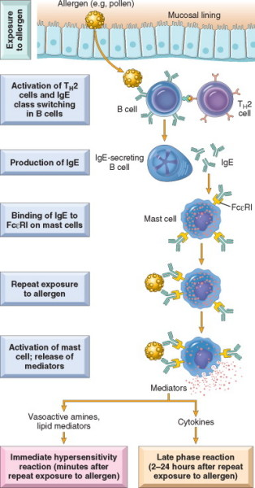
MAST CELL MEDIATORS: Released via two parallel processes, mast cell degranulation (primary mediators) and de novo synthesis (secondary mediators)
- Primary Mediators
  - Biogenic Amines
- Eg Histamine
- Causes smooth muscle contraction, increased vascular permeability, and increased glandular secretion
  - Enzymes
- Neutral proteases eg Tryptase
- Acid Hydrolases
- Cause tissue damage, generation of kinins, and complement activation
  - Proteoglycans
- Eg Heparin- anticoagulant
- Store and package other mediators
- Secondary Mediators
  - Lipid mediators- come from membrane phospholipids
    - Via arachidonic acid metabolism
      - Leukotrienes
- Eg LB4, LC4, LD4
- Vasoactive
- Spasmogenic
- LB4 is chemotactic
      - Prostaglandin D2
- Causes intense bronchospasm and increased mucous secretion
    - PAF (Platelet activating factor)
- Causes platelet aggregation, release of histamine, bronchospasm
  - Cytokines
    - Eg TNF, IL-4, IL-6, chemokines
    - Cause inflammatory response
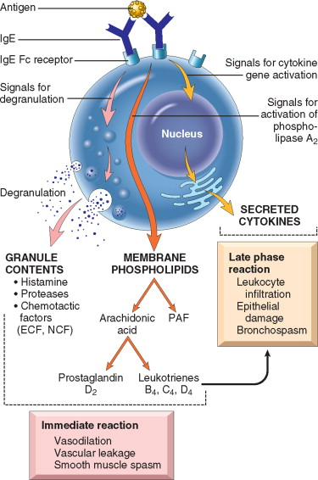
THE ROLE OF COMPLEMENT IN INFLAMMATION

DEFINITION: The complement system consists of 20 componant proteins and their cleavage products, which are found in greatest concentration in plasma. This system functions in both innate and adaptive immunity for defence against microbial agents.

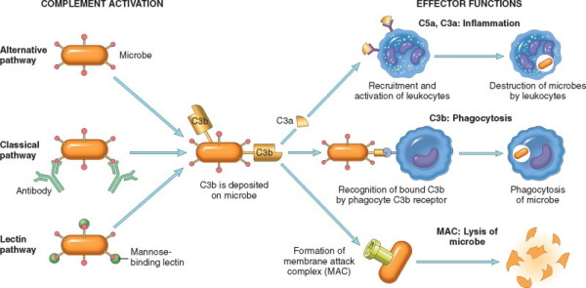

FUNCTIONS: Fall into two general categories
- Cell lysis by the MAC
- Effects of complement fragments
  - Vascular phenomena
    - Mediated by C3a, C5a, and C4a (anaphylatoxins)
    - Stimulate histamine release
      - Increases vascular permeability
      - Increases vasodilation
    - C5a activates the lipoxygenase pathway of AA metabolites
  - Leukocyte adhesion, chemotaxis, and activation
    - C5a
  - Phagocytosis
    - C3b and iC3b act as opsonins

C3 and C5 are the most important inflammatory mediators and can be activated by several proteolytic enzymes present in inflammatory exudate

NEPHROTIC SYNDROME

DEFINITION: A clinical complex resulting from various glomerular diseases, and manifesting as:
- Massive proteinuria (3.5g or more per day)
- Hypoalbuminaemia
- Generalised oedema
- Hyperlipidaemia
- Lipiduria

PATHOPHYSIOLOGY:
- Increased permeability of glomerular capillary walls to plasma proteins
  - Resulting from either structural or physiochemical alterations
  - Allows protein to escape
  - Massive proteinuria
- Depletion of serum albumin levels
  - Secondary to increased permeability of glomerular capillary walls
  - Liver synthesis is unable to compensate
  - Increased renal catabolism of filtered albumin
  - Hypoalbuminaemia
  - Reversal of the albumin:globulin ratio
- Generalised oedema
  - Loss of colloid osmotic pressure and accumulation of fluid in interstitial tissues
  - Sodium and water retention
    - Compensatory secretion of aldosterone
    - Stimulation of the sympathetic system
    - Reduction in secretion of natriuretic factors
- Hyperlipidaemia
  - Complex pathophysiology
    - Increased synthesis of lipoproteins in the liver
    - Abnormal transport of circulating lipid particles
    - Decreased catabolism
- Lipiduria
  - Leakage of lipids across the glomerular capillary membrane
  - Increased lipid production

CAUSES
TABLE 20-7 -- Cause of Nephrotic Syndrome
 | Prevalence (%)[*]
Causes | Children | Adults
PRIMARY GLOMERULAR DISEASE
Membranous glomerulopathy | 5 | 30
Minimal-change disease | 65 | 10
Focal segmental glomerulosclerosis | 10 | 35
Membranoproliferative | 10 | 10
glomerulonephritis[†] | 10 | 15
Other proliferative glomerulonephritides (focal, “pure mesangial,” IgA nephropathy)[†] | 10 | 15
SYSTEMIC DISEASES
Diabetes mellitus
Amyloidosis
Systemic lupus erythematosus
Drugs (nonsteroidal anti-inflammatory, penicillamine, “street heroin”)
Infections (malaria, syphilis, hepatitis B and C, HIV)
Malignant disease (carcinoma, lymphoma)
Miscellaneous (bee-sting allergy, hereditary nephritis)

CAUSES:
- 95% of nephrotic syndrome in children is caused by primary glomerular disease
  - Of these, 65% are caused by minimal change disease
  - The remainder (10% each) are focal segmental glomerulosclerosis, membranoproliferative glomerulonephritides, other proliferative glomerulonephritis, and membranous glomerulopathy (5%)
- 60% of nephrotic syndrome in adults is caused by primary glomerular disease
  - 35% of these are caused by focal segmental glomerulosclerosis
  - 30% by membranous glomerulopathy
  - 15% by other proliferative glomerulonephritis
- The remaining 40% of adult nephrotic syndrome is caused by systemic disease
  - Diabetes
  - Amyloidosis
  - SLE
  - Drugs (esp NSAIDS)
  - Infections (Malaria, Viral hepatitis)
  - Malignancy

PERNICIOUS ANAEMIA

DEFINITION: A specific form of megaloblastic anaemia caused by atrophic gastritis and an attendant failure of intrinsic factor production that leads to vitamin B12 deficiency

PATHOGENESIS:
- Immunologically mediated destruction of gastric mucosa (parietal cells)
  - May be autoimmune
  - Leads to:
    - Loss of gastric acid
    - Loss of intrinsic factor
    - Both of these are made exclusively by parietal cells
  - Results in chronic atrophic gastritis
- Development of Vitamin B12 deficiency resulting in
  - Loss of gastric acid
    - Interferes with initial availability of B12
    - Stomach acid is required to release B12 from food
  - Loss of intrinsic factor
    - Results in impaired absorption of B12 in the terminal ileum
- Defective DNA synthesis and impaired red cell formation
  - B12 deficiency results in depleted stores of tetrahydrofolate
  - Results in lowered purine production
  - Inadequate DNA synthesis causes defective nuclear maturation, with a delay or block in cell division
  - Megaloblastic anaemia with erythroid precursors results
- The role of antibodies
  - Three types of antibodies are present in many but not all patients with pernicious anaemia
    - Type I antibody
      - 75% of patients
      - blocks the binding of IF to B12
    - Type II antibody
      - prevents the binding of the IF-B12 complex to ileal receptors
    - Type III antibody
      - 85-95% of patients
      - recognises the α- and β-subunits of the gastric proton pump

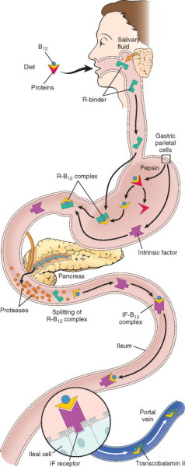

CLINICAL MANIFESTATIONS
Diagnostic features:
- Moderate to severe megaloblastic anaemia
- Leukopenia
- Thrombocytopaenia
- Mild jaundice
- Neurological changes related to involvement of the posterolateral spinal tracts
  - Spastic paresis
  - Sensory ataxia
  - Severe parasthesias

Other clinical features:
- Atrophic glossitis
- Weakness
- Tiredness
- Pallor
HEPATITIS D VIRUS

DEFINITION: A unique enveloped ssRNA viroid-like virus that is replication defective, causing infection only when it is encapsulated by HBsAg. HDV is a 35nm, double shelled particle with a HBsAg outer coat and an internal HDAg (delta antigen) polypeptide with an associated single strand of circular RNA.

TRANSMISSION: Parenteral; close contact

INCUBATION: 4-7 weeks

CAUSES INFECTION BY:
- Acute coinfection with HDV and HBV
  - Hepatitis ranging from mild to fulminant
  - Chronicity rare
  - Fulminant disease more likely than with HBV alone
- Superinfection of chronic HBV carrier with a new inoculum of HBV and HDV causing:
  - Acute, severe hepatitis in a previous healthy carrier
  - Mild HBV hepatitis conversion to fulminant disease
  - Chronic progressive disease
    - In 80% of patients
    - Often progresses to cirrhosis

SEROLOGIC DIAGNOSIS

- HDV RNA- detectable just prior to and at the start of symptoms
- IgM anti-HDV- appears late, is short-lived, but is most reliable

HEPATITIS C

DEFINITION: A small, enveloped ssRNA virus in the Flaviviridae family that is inherently unstable, giving rise to multiple genotypes and subtypes; this antigenic variability means that elevated titres of anti-HCV IgG do not confer effective immunity.

ROUTES OF TRASMISSION:
- Blood inoculation via IVDU- 60%
- Blood transfusion prior to 1991- 10%
- Haemodialysis- <5%
- Occupational exposure- <5%
- Sexual transmission infrequent
- Vertical transmission low

INCUBATION: 2-26 weeks

OUTCOMES OF INFECTION: Acute infection is generally undetectable clinically. Progression to chronic disease occurs in the majority of infected individuals.

- Resolution 15%
- Chronic hepatitis 85%
  - Stable disease 80%
  - Cirrhosis 20%
    - Stable
    - Hepatocellular carcinoma
    - Death

SEROLOGIC DIAGNOSIS
- HCV RNA 1-3 weeks with increased transaminases
- Anti-HCV Ab after 3-6 weeks

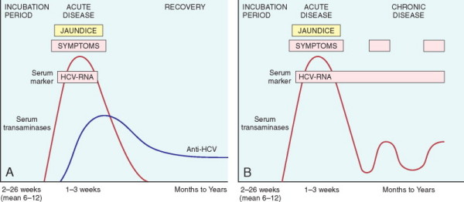

VON WILLEBRAND DISEASE

DEFINITION: A common inherited disorder of bleeding (usually autosomal dominant) caused by defects in the factorVIII-vWF complex. Two main categories:

- Reduced quantity of circulating vWF
  - Type 1
    - Most common (70%)
    - Autosomal dominant
    - Usually mild disease
  - Type 3
    - Autosomal recessive
    - Severe
- Qualitative defects in vWF
  - Type 2
    - 25%
    - Several subtypes
    - Type 2a most common
    - Autosomal dominant
    - Mild to moderate disease bleeding

HAEMOTOLOGICAL FEATURES

- Prolonged bleeding time
- Normal platelet count
- Reduced plasma vWF level (ristocetin cofactor activity)
- Decreased FactorVIII levels and prolonged PTT- (Types 1 and 3)

CLINICAL FEATURES

- Spontaneous bleeding from mucous membranes
- Excessive bleeding from wounds
- Menorrhagia
- Bleeding into joints is uncommon except in severe cases

ASBESTOS RELATED LUNG DISEASE

Asbestos is a family of crystalline hydrated silicates that form fibres. Occupational exposure is linked to:
- Localised fibrous plaques
- Diffuse pleural fibrosis (rare)
- Pleural effusions
- Parenchymal interstitial fibrosis
- Lung carcinoma
- Mesothelioma
- Laryngeal and other extrapulmonary neoplasms

PATHOPHYSIOLOGY
- May act as a tumour initiator and promoter
- Absorbs the carcinogens in cigarette smoke
- Initial injury occurs at the bifurcation of the small airways
- Macrophages attempt to ingest the asbestos and are activated
- Release of mediators
- Generalised interstitial pulmonary inflammation and interstitial fibrosis

Two types of asbestos:
- Serpentine
  - Curly and flexible
  - Impacts in the upper airways
  - The most common form used in industry
  - Less pathogenic
- Amphibole
  - Straight, stiff, and brittle
  - Penetrate the epithelial cells deep in the lung to reach the interstitium
  - The only form of asbestos to correlated with mesothelioma

LUNG CANCER AND ASBESTOS

- The most frequent malignancy in people exposed to asbestos
- Increased (5 times) incidence among asbestos exposed people
- 50-90 times greater chance of lung cancer in asbestos workers that smoke
- 1 in 5 asbestos workers die from lung CA
- 1 in 10 die from mesothelioma
- 1 in 10 die from GI carcinoma

MALIGNANT MESOTHELIOMA OF THE LUNG: A diffuse lesion that spreads widely in the pleural space and is usually associated with extensive pleural effusion and direct invasion of thoracic structures; it may arise from either the parietal or the visceral pleura. May also arise in:
- Peritoneum
- Pericardium
- Tunica vaginalis
- Genital tract

Relationship to asbestos:

- Lifetime risk of mesothelioma in heavily exposed individuals is 7-10%
- Latent period of 25-45 years
- No increased risk of mesothelioma in exposed individuals that smoke
- Increased numbers of asbestos bodies and asbestos plaques

THROMBUS FORMATION
VIRCHOW’S TRIAD

- Endothelial injury
  - Any disruption in the pro- and anti-thrombin effects of endothelium
  - Most important in areas with high flow rates
    - Arterial circulation
    - Heart
  - Exposure of ECM
  - Adhesion of platelets
  - Release of tissue factor
  - Local depletion of PGI2 and PA’s
  - Significant endothelial stress in the absence of endothelial cell loss may occur with:
    - HTN
    - Scarred valves
    - Bacterial endotoxins
- Alterations in Flow
  - Turbulance and stasis
  - Disrupts laminar flow
  - Brings platelets into contact with endothelium
  - Prevents dilution of clotting factors
  - Hinders inflow of clotting factor inhibitors
  - Promotes endothelial cell activation
- Hypercoagulability
  - An important but less frequent cause
  - Any alteration in the coagulation pathways
  - Primary
    - Antithrombin III deficiency
    - Protein C & S deficiency
    - Factor V Leiden mutation
    - Prothrombin gene mutation
  - Secondary
    - Bed rest/immobilisation
    - AF
    - Malignancy
    - Mechanical heart valves
    - DIC
    - Antiphospholipid antibody syndrome
    - Hyperoestrogenic states
    - Sickle cell anaemia
    - Smoking

TYPE IV HYPERSENSITIVITY (CELL MEDIATED)

DEFINITION: Cellular and tissue injury secondary to the actions of sensitised T-lymphocytes; it includes delayed type hypersensitivity reactions mediated by CD4+ T cells and direct cell cytotoxicity mediated by CD8+ T cells.

INITIAL EVENTS IN A NON-SENSITISED INDIVIDUAL
- Macrophages and dendritic cells presenting microbial antigen, in association with class II MHC molecules, secrete IL-12
- IL-12 drives the differentiation of naïve CD4+ helper cells to TH1 cells
- TH1 cells secrete IL-2, IFN-γ, and TNF
- Some TH1 cells enter the circulation and may remain in the T cell memory pool for long periods
- On reintroduction of the antigen, the TH1 cells become activated and secrete cytokines

DELAYED TYPE HYPERSENSITIVITY
- TH1 cells secrete cytokines (IFN-γ)
- Macrophage activation
  - Augmentation of phagocytosis
  - Expression of more class II MHC molecules, increasing antigen presentation
  - Secretion of PDGF leading to fibroblast proliferation and augmentation of collagen synthesis
  - Secretion of TNF, IL-1, chemokines, and IL-12
- Morphology:
  - Accumulation of mononuclear cells around small veins and venules (perivascular cuffing)
  - Increased microvascular permeability
  - Dermal oedema due to escaped plasma proteins
  - Interstitial fibrin deposition
- Examples:
  - Tuberculin reaction
  - Contact dermatitis
  - DMT1
  - Multiple sclerosis

T-CELL MEDIATED CYTOTOXICITY

- Sensitised CD8+ T-cells kill antigen-bearing cells
- Example: Graft rejection

NIESSERIAL INFECTIONS

DEFINITIONS: Aerobic gram positive diplococci that are flattened on the adjoining sides; contains endotoxin. Two clinically significant types:

- Niesseria meningitides (Meningococcus)
  - Causes bacterial meningitis age 5-19
  - Colonises the oropharynx
  - Spread by the respiratory route
  - Has a polysaccharide capsule that enhances virulence by its antiphagocytic action
  - 13 serotypes based on polysaccharide antigenicity
- Niesseria gonorrhoea
  - A sexually transmitted disease causing urethritis in men; may be clinically silent in women or lead to PID
  - Disseminated infection may cause septic arthritis
  - Multiple serotypes based on the antigenicity of the pilus protein

PATHOGENESIS OF N. MENINGITIDES

- Colonisation of the oropharynx
  - 10% of the population are carriers at any one time
  - Carriers are asymptomatic
  - Each colonisation lasts for several months
- Spread via respiratory droplet
  - Outbreaks occur in crowded quarters e.g. dormitories
- Invasive disease
  - Crosses the respiratory epithelium to enter the blood
  - Affects:
    - Meninges
    - Joints
    - Disseminated

VIRULENCE FACTORS:

- Polysaccharide capsule
  - Resists opsonisation and phagocytosis
- Endotoxin (LPS)
  - Causes fever and shock
- IgA protease
  - Helps bacteria attach to the upper respiratory tract membranes

VITAMIN K

DEFINITION: A vitamin that is a required co-factor for a liver microsomal carboxylase that is necessary to convert glutamyl residues in protein precursors to γ- carboxyglutamates. Carboxylation provides Ca2+ binding sites; vitamin K is therefore necessary for the functional activity of many proteins:
- Clotting factors II, VII, IX, X
- Protein C
- Protein S
- Osteocalcin

CAUSES OF VITAMIN K DEFICIENCY:
- Fat malabsorption syndromes
- Destruction of endogenous Vitamin-K synthesising flora
- During the neonatal period
- Diffuse liver disease

TYPE II HYPERSENSITIVITY – Antibody mediated

DEFINITION: An immune reaction mediated by antibodies directed towards antigens present on cell surfaces or extracellular matrix. There are three different antibody dependent mechanisms involved:

- Opsonisation and complement- + Fc receptor-mediated phagocytosis
  - Transfusion reaction
  - Erythroblastosis fetalis
  - Autoimmune haemolytic anaemia, thrombocytosis, and agranulocytosis
  - Drug reactions
- Complement- and Fc-receptor mediated inflammation
  - Glomerulonephritis
  - Vascular rejection in organ grafts
- Antibody mediated cellular dysfunction
  - Myasthenia gravis
  - Pemphigus vulgaris
  - Grave’s disease

MECHANISMS:
- Opsonisation and complement- + Fc receptor-mediated phagocytosis
  - Cell opsonised by:
    - Complement components (C3b, C4b)
    - IgG antibody
  - Phagocyte recognition of cell via C3b receptors and Fc receptors
  - Phagocytosis
  - Alternative mechanism: Antibody dependent cytotoxicity
    - Cells are coated with IgG antibody
    - Bind to Fc receptors
    - Cell lysis without phagocytosis
- Complement- and Fc-receptor mediated inflammation
  - Antibody deposits on the extracellular matrix
  - Activation of complement
  - Generation of complement by-products (C5a)
  - Neutrophil and monocyte recruitment and binding to antibody Fc receptor
  - Leukocyte activation
  - Release of enzymes and ROS
  - Tissue damage
- Antibody mediated cellular dysfunction
  - Antibody directed against cell surface receptors
  - Impairment or dysregulation of function without inflammation or injury

MYCOBACTERIUM TUBERCULOSIS

DEFINITION: Slender, weakly gram positive, acid-fast aerobic bacilli in the mycobacterium genus. They have a waxy cell wall composed of mycolic acid.

PATHOGENESIS IN A PREVIOUSLY UNEXPOSED, IMMUNOCOMPETENT PERSON
- Transmission: person to person spread via respiratory droplet
- 0-3 weeks
  - M. tuberculosis enters alveolar macrophages via endocytosis
    - Mediated by mannose receptors
  - M. tuberculosis replicates in macrophage phagosomes
    - Blocks fusion of the phagosome and lysosome via:
      - Inhibition of calcium signals
      - Blockage of recruitment and assembly of proteins
  - Bacteraemia and seeding
    - Patient remains asymptomatic or has a mild flu-like illness
- After 3 weeks- immunity through type IV hypersensitivity reaction (T-cell mediated delayed type)
  - Mycobacterial antigens in lymph nodes are presented with class II MHC proteins by the antigen presenting complex
  - APC produces IL-12 drives the differentiation of T cells to TH1 cells
  - Mature TH1 cells:
    - Produce IFN-γ
      - Stimulates formation of phagolysosomes
      - Expression of NO
      - Macrophages become bactericidal
    - Formation of granulomas and caseous necrosis
      - IFN-γ stimulates TNF production
      - TNF recruits monocytes
      - Monocytes become epithelial histiocytes
      - Formation of epitheliod granuloma
- Reactivation and re-exposure
  - Rapid defence response with increased tissue necrosis
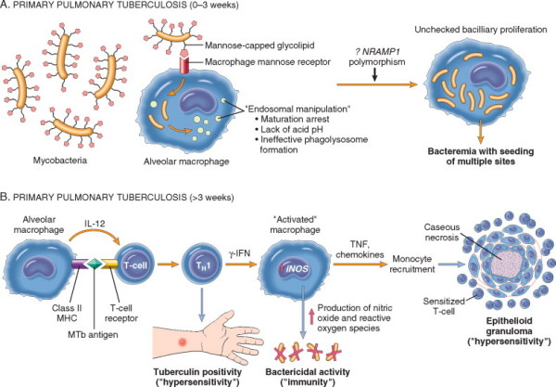
MORPHOLOGY OF PRIMARY TB
- Inhaled bacilli implant in the distal airspaces of the lower part of the upper lobe, or the upper part of the lower lobe, close to the pleura
- Formation of Ghon focus:
  - Sensitisation develops
  - 1-1.5cm area of grey-white inflammatory consolidation
  - Central caseous necrosis
- Formation of Ghon complex:
  - TB bacilli drain to regional nodes
  - May caseate
- Lymphatic and haematogenous dissemination
  - 95% of cases
  - Type IV hypersensitivity controls the infection
- Ghon complex undergoes fibrosis +/- calcification

CLINICAL FEATURES- PRIMARY TB
Develops in a previously unexposed and unsensitised person.
- 5% of people develop clinically significant disease
- The source of the infection is exogenous
- Most patients progress to latent disease
- Progressive primary TB usually presents similar to infective pneumonia:
  - Middle and lower lobe consolidation
  - Hilar adenopathy
  - Pleural effusion
  - Cavitation is rare
- Complications include:
  - Lymphohaematogenous spread
    - TB meningitis
    - Miliary TB
  - Secondary TB
    - A pattern of disease arising in a previously sensitised host
THE NATURAL HISTORY OF TB
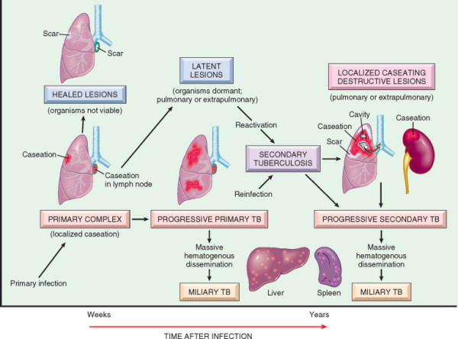
CLOSTRIDIAL INFECTIONS

DEFINITION: Gram positive anaerobic bacilli that produce spores. There are four types of clostridial infections, each of which cause disease via secretion of toxins and/or enzymes:

- Clostridium perfringens and clostridium septicum
- Clostridium tetani
- Clostridium botulinum
- Clostridium difficile

CLOSTRIDIUM PERFRINGINS AND CLOSTRIDIUM SEPTICUM
- Clinical effects from:
  - Toxins
    - 14 different toxins
    - Enterotoxin
      - Forms pores in epithelial cell membranes
      - Cell lysis
    - α-toxin (most important)-a phospholipase C with multiple actions:
      - Degrades lecithin (major cell membrane component)
        - Red cell, platelet, and muscle cell destruction (myonecrosis)
      - Sphingomyelinase activity
        - Nerve sheath damage
      - Release of prostaglandins and thromboxanes
        - Cell death
  - Enzymes
    - Collagenase
    - Hyaluronidase
    - Contribute to bacterial invasiveness
- Clinical syndromes:
  - Gas gangrene
    - Cellulitis and myonecrosis
    - Gas bubbles formed by bacterial fermentation
    - Massive proteolytic action of enzymes causes tissues to become inflamed, soft, blue-black, friable, and semi-fluid
  - Food poisoning
    - Caused by spores in contaminated meat
  - Sepsis

CLOSTRIDIUM TETANI
- Clinical effects from:
  - Neurotoxin (tetanospasm)
    - Blocks release of γ-aminobutyric acid from motor neurons
- Clinical syndrome:
  - Tetanus
    - Violent spastic paralysis

CLOSTRIDIUM BOTULINUM
- Clinical effects from:
  - Neurotoxin (botulism toxin)
  - Binds gangliosides on motor neurons
  - Transported into the cell
  - The ‘A’ fragment of botulism toxin cleaves synaptobrevin
  - This prevents the release of acetylcholine at the neuromuscular junction
- Clinical syndrome:
  - Botulism
    - Severe flaccid paralysis

CLOSTRIDIUM DIFFICILE
- Clinical effects from:
  - Overgrowth over other intestinal flora (e.g. post Abx)
  - Release of endotoxins
    - Endotoxin A- enterotoxin
      - Stimulates chemokine production
      - Attracts leukocytes
    - Endotoxin B- cytotoxin
      - Depolymerisation of actin
      - Loss of cytoskeletal integrity
      - Apoptosis of enterocytes
  - Fibropurulant-necrotic debris adhering to damaged colonic mucosa
- Clinical syndrome:
  - Pseudomembranous colitis: an acute colitis characterised by formation of an adherent layer of inflammatory cells and debris overlying sites of injury

TYPE III HYPERSENSITIVITY- IMMUNE COMPLEX MEDIATED

DEFINITION: Antigen-antibody complexes produce tissue damage by eliciting inflammation at the sites of deposition either directly or by activation of complement; antigens may be either exogenous or endogenous. The disease produced may be generalised (systemic immune complex disease) or localised (local immune complex disease, arthus reaction).

PATHOGENESIS:

- Formation of antigen-antibody complexes in the circulation (PHASE 1)
  - Introduction of the antigen
  - Antibody formation occurs ~1 week later
  - Formation of the Ag-Ab complex
- Tissue deposition of immune complexes in various tissues (PHASE 2)
  - Increased vascular permeability
    - Immune complexes bind to inflammatory cells via Fc or C3b receptors
    - Release of vasoactive mediators
    - Release of cytokines
  - Influences leading to tissue deposition
    - Small or intermediate size complexes bind less avidly to phagocytes and circulate longer
    - Mononuclear phagocyte system dysfunction
    - Charge of immune complexes
    - Valency of antigen
    - Antigen affinity to tissue component
    - Structure of complexes
  - Favoured sites of inflammation
    - Joints
    - Skin
    - Heart
    - Serosal surfaces
    - Small blood vessels
- Inflammatory response (PHASE 3)
  - 10 days after antigen administration
  - Activation of complement
    - Production of chemotactic factors
    - Release of anaphylatoxins
  - Activation of neutrophils and macrophages via their Fc receptors
  - Leukocytes release:
    - Prostaglandins
    - Vasodilator peptides
    - Lysosomal enzymes
    - Free radicals

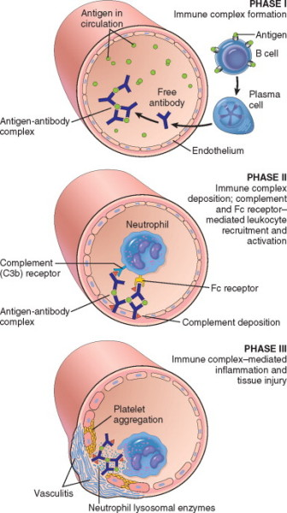

EXAMPLES OF IMMUNE COMPLEX MEDIATED DISEASE
- SLE
- Polyarteritis nodosa
- Post-streptococcal glomerulonephritis
- Acute glomerulonephritis
- Reactive arthritis
- Arthus reaction
- Serum sickness

HEPATITIS B VIRUS

DEFINITION: A partially double-stranded circular DNA virus from the hepadnaviridae family; contains a nucleocapsid ‘core’ protein (HBcAg) with a longer polypeptide transcript (HBeAg). There is also an envelope glycoprotein (HBsAg).

TRANSMISSION:
- Transfusion
- Blood products
- Dialysis
- Needle stick accidents
- IVDU
- Homosexual activity
- Vertical transmission

INCUBATION: 4-26 weeks

DISEASE STATES:
- Acute hepatitis with resolution
- Chronic hepatitis +/- cirrhosis
- Fulminant hepatitis with massive liver necrosis
- Backdrop for HDV infection
- Development of hepatocellular carcinoma

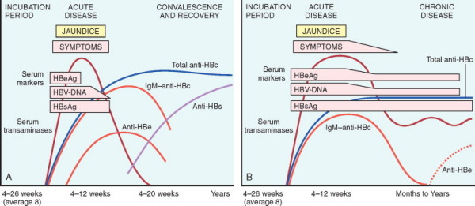

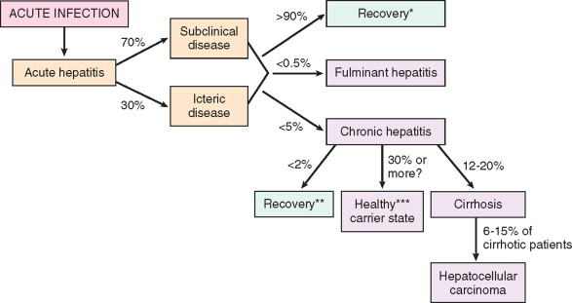
COMPARE CHRONIC BRONCHITIS AND EMPHYSEMA

TABLE 15-4 -- Emphysema and Chronic Bronchitis
 | Predominant Bronchitis | Predominant Emphysema
Age (yr) | 40–45 | 50–75
Dyspnea | Mild; late | Severe; early
Cough | Early; copious sputum | Late; scanty sputum
Infections | Common | Occasional
Respiratory insufficiency | Repeated | Terminal
Cor pulmonale | Common | Rare; terminal
Airway resistance | Increased | Normal or slightly increased
Elastic recoil | Normal | Low
Chest radiograph | Prominent vessels; large heart | Hyperinflation; small heart
Appearance | Blue bloater | Pink puffer

COURSE AND PATHOGENESIS OF HIV

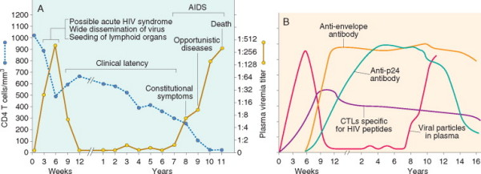

FIGURE 6-48 Clinical course of HIV infection. A, During the early period after primary infection there is dissemination of virus, development of an immune response to HIV, and often an acute viral syndrome. During the period of clinical latency, viral replication continues and the CD4+ T-cell count gradually decreases, until it reaches a critical level below which there is a substantial risk of AIDS-associated diseases. B, Immune response to HIV infection. A cytotoxic T lymphocyte (CTL) response to HIV is detectable by 2 to 3 weeks after the initial infection, and it peaks by 9 to 12 weeks. Marked expansion of virus-specific CD8+ T-cell clones occurs during this time, and up to 10% of a patient's CTLs may be HIV specific at 12 weeks. The humoral immune response to HIV peaks at about 12 weeks.

